SECTION 2
SECTION 1
(FPR) Facilities Project Request - FLOWCHART

11-5-18

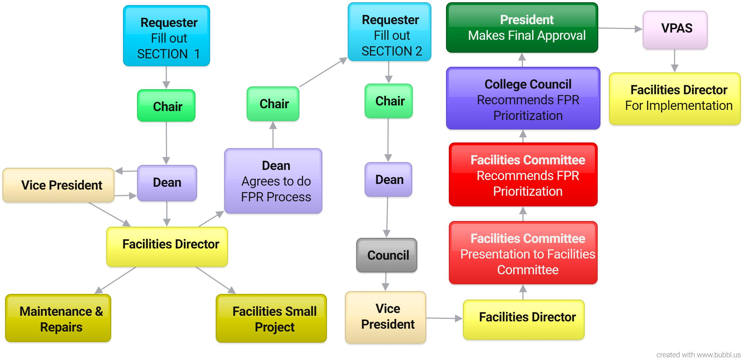

STEP 1 Fill out SECTION 1 Facilities Project Request (FPR) form. SECTION 1 is a prerequisite to starting the FPR process that goes through the Facilities Committee. Follow the flowchart for approvals and signatures.

STEP 2 Fill out SECTION 2 Facilities Project Request (FPR) form after SECTION 1 signatures are completed.
NOTE: The scope of work may have changed from SECTION 1. Follow the flowchart for approvals and signatures.

STEP 3 The Facilities Committee may ask for a brief presentation/Q&A.

FPR TIMELINE FOR 2019
Mar 15 Facilities Director sends out FPR form to the campus
April 3 Requester turns in SECTION 1 to their Chair/Supervisor
April 12 Dean turns in SECTION 1 to Facilities Director with signatures from Chair/Supervisor,
Dean/Director, and VP
May 24 Vice President turns in SECTION 2 to Facilities Director (If Approved) with signatures from
Chair/Supervisor, Dean/Director, and VP along with the Council (AAC, ASC, SSC) review date
June, July & August - No Facilities Committee meeting -
Aug 19 Facilities Director sends out FPR reports and scorecards to the Facilities Committee
Sept 4 First Facilities Committee meeting after summer and the start of the FPR prioritization
Nov 6 Facilities Committee recommends FPR prioritization to College Council
Nov College Council recommends to President
Facilities Project Request (FPR) – Grossmont Facilities Committee
SECTION 1 – Condensed Summary: This section is to determine if the request should go through the FPR process and allows for an initial cost/impact analysis and/or fast track to Maintenance/Operations. Provide a brief summary of the project by completing the items below and submit to your Chair/Supervisor.
Requestor/Primary Contact: Phone Extension:
Department/Program: Date:
Brief Project Name: Project Number:
(Brief phrase identifying need such as “Foreign language lab space expansion”) (Facilities Director fills this in)
Project Location (building/room number):
- Project Description (please be specific, thorough, and attach a drawing or sketch of the proposed project if possible):

- The project relates to or involves: (check all that apply):
Audiovisual, computers, data, software or phones
Building/structure modification or new construction
Electrical, mechanical, plumbing
Extensive labor/time for Facilities/Maintenance staff
Landscape/outdoor project
New furniture (not for individual offices)
Reconfiguration of furniture
Reconfiguration of the layout of a shared space
Other (i.e., health/safety – please explain):

- State briefly how this project affects students and how many will be directly affected:

- List how this project has been planned for (i.e., within Program Review, Facilities Master Plan, Strategic Plan, new program or new curriculum):

- List the other departments, programs, or services that may be impacted by this project:

- Estimated Cost (if known): Potential/Recommended funding source:

- When is this project needed?
--------------------------------------------------------------------------------------------------------------------------------------------------------
Chair/Supervisor (print name & signature): Date
Dean/Director (print name & signature): Date
Vice President (print name & signature): Date
Facilities Director (print name & signature): Date
If it is determined by the signatures above that the project should go through the FPR process, then the requester will fill out SECTION 2 for the Facilities Committee.
(Refer to FPR Process Flowchart)

SECTION 2
SECTION 1
(FPR) Facilities Project Request - FLOWCHART

STEP 1 Fill out SECTION 1 Facilities Project Request (FPR) form. SECTION 1 is a prerequisite to starting the FPR process that goes through the Facilities Committee. Follow the flowchart for approvals and signatures.

STEP 2 Fill out SECTION 2 Facilities Project Request (FPR) form after SECTION 1 signatures are completed.
NOTE: The scope of work may have changed from SECTION 1. Follow the flowchart for approvals and signatures.

STEP 3 The Facilities Committee may ask for a brief presentation/Q&A.

FPR TIMELINE FOR 2019
Mar 15 Facilities Director sends out FPR form to the campus
April 3 Requester turns in SECTION 1 to their Chair/Supervisor
April 12 Dean turns in SECTION 1 to Facilities Director with signatures from Chair/Supervisor,
Dean/Director, and VP
May 24 Vice President turns in SECTION 2 to Facilities Director (If Approved) with signatures from
Chair/Supervisor, Dean/Director, and VP along with the Council (AAC, ASC, SSC) review date
June, July & August - No Facilities Committee meeting -
Aug 19 Facilities Director sends out FPR reports and scorecards to the Facilities Committee
Sept 4 First Facilities Committee meeting after summer and the start of the FPR prioritization
Nov 6 Facilities Committee recommends FPR prioritization to College Council
Nov College Council recommends to President
Facilities Project Request (FPR) – Grossmont Facilities Committee
Complete this section ONLY when notified to do so by your Dean/Director
(Refer to FPR Process Flowchart)
FPR#
SECTION 2 - If the Facilities Project Request (FPR) has received approval to move forward, please respond to the following questions. Attach drawings, photos, or backup documentation if appropriate. Only SECTION 2 goes to the Facilities Committee.

Requestor/Primary Contact: Phone Extension:
Department/Program: Date:
Brief Project Name: Project Number:
(Brief phrase identifying need such as “Foreign language lab space expansion”) (Facilities Director fills this in)
Project Location (building/room number):

1. Project Description (please be specific, thorough, and attach a drawing or sketch of the proposed project if possible):

2. Describe how the project relates to each item:
- Audiovisual, computers, data, software or phones:
- Building/structure modification or new construction:
- Electrical, mechanical, plumbing:
- Extensive labor/time for Facilities/Maintenance staff:
- Landscape/outdoor project:
- New furniture (not for individual offices):
- Reconfiguration of furniture:
- Reconfiguration of the layout of shared space:
  - Other (i.e., health/safety – please explain):

3. Describe how this project will directly or indirectly benefit students, and how many students will be affected. What is the impact on students if the project is NOT implemented?

4. Describe where this project has been planned for and attach documentation (i.e., Recommendation from Program Review Committee; the primary or secondary goal of the department/program annual plan; college or district Facilities Master Plan, item number on Strategic Plan):

5. Describe the impact on other departments, services or programs if this project is completed:

6. Describe how this project meets sustainability and accessibility principles:
(Sustainability = minimal environmental impact. Accessibility =promotes maximum independence and integration for students with disabilities)

7. Provide a cost analysis of the project:
- What is the cost impact of this project - are the costs one-time or ongoing? How so?
- What are the projected long-term costs?
- What is the ‘life expectancy’ of the project?
- What are the potential and/or recommended funding sources? (department, division, categorical, grant, foundation, general fund, other)

8. Describe the timeline for the project (Is the project urgent – how so?):

-----------------------------------------------------------------------------------------------------------------------------------------------------
ALL signatures are required to proceed to the Facilities Committee

Chair/Supervisor (print name & signature): Date

Dean/Director (print name & signature): Date
☐ AAC Review Date ☐ ASC Review Date ☐ SSC Review Date

Vice President (print name & signature): Date

Facilities Director (print name & signature): Date
-----------------------------------------------------------------------------------------------------------------------------------------------------
ALL signatures are required to proceed to College Council

Co-Chair of Facilities Committee (print name & signature): Date

Co-Chair of Facilities Committee (print name & signature): Date
-----------------------------------------------------------------------------------------------------------------------------------------------------
ALL signatures are required to proceed to the President of the College

(Print name & signature): Date
Convener of College Council

-----------------------------------------------------------------------------------------------------------------------------------------------------
Signature is required to proceed to the President of the College

Project Approved

(Print name & signature): Date
President of Grossmont College

